

Mathematics Specialist Unit 1

Test 2

Circle Geometry, Vector Proof and Numerical Proof

Name: ______________________ Total Marks:______/50

Task type: Response

Time allowed for this task: 55 minutes, in-class, under test conditions

Materials required: Calculator with CAS capability (to be provided by the student),
1 A4 page of notes two sided

Standard items: Pens (blue/black preferred), pencils (including coloured), sharpener, correction fluid/tape, eraser, ruler, highlighters

Special items: Drawing instruments, templates, notes on one unfolded sheet of
A4 paper, and up to three calculators approved for use in the WACE examinations
Formula sheet

Marks available: 50 marks

Task weighting: 5%

Question 1
[8 marks]
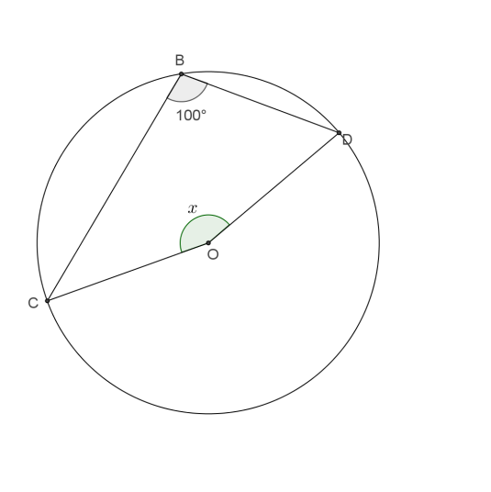
- Find the value of$x$, showing appropriate reasoning.

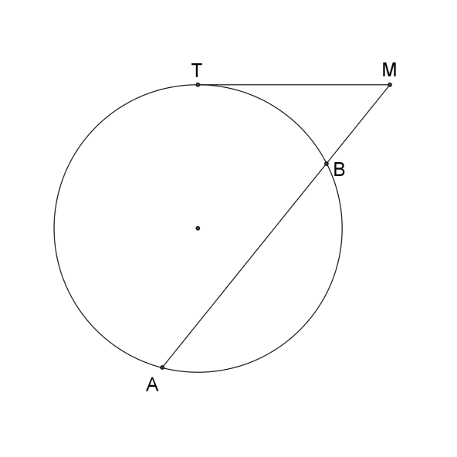
- Given that TM=6m and BM=4m. Find AB

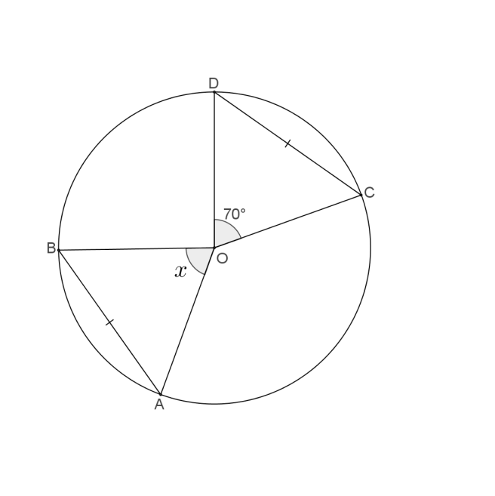
- Find the value of$x$, showing appropriate reasoning.

Question 2
[5 marks]
In the diagram below EA and EC are tangents to the curve
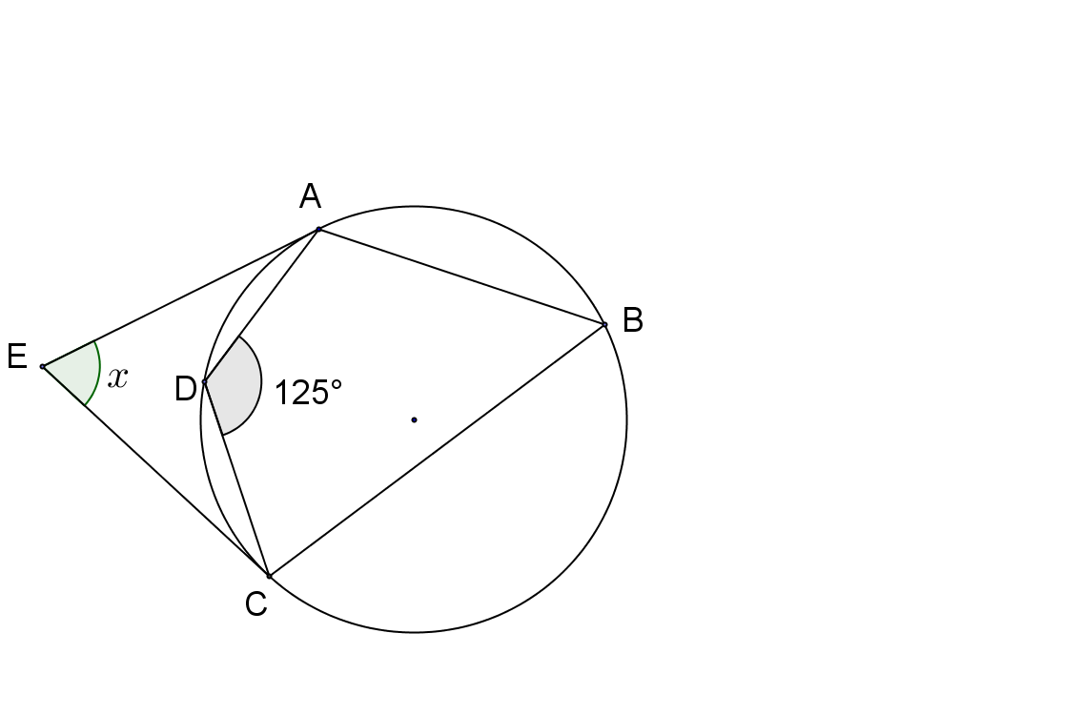
$∠AEC=x° .$Prove that $x=70$

Question 3
[6 marks]
Prove that CE is the diameter of the circle.
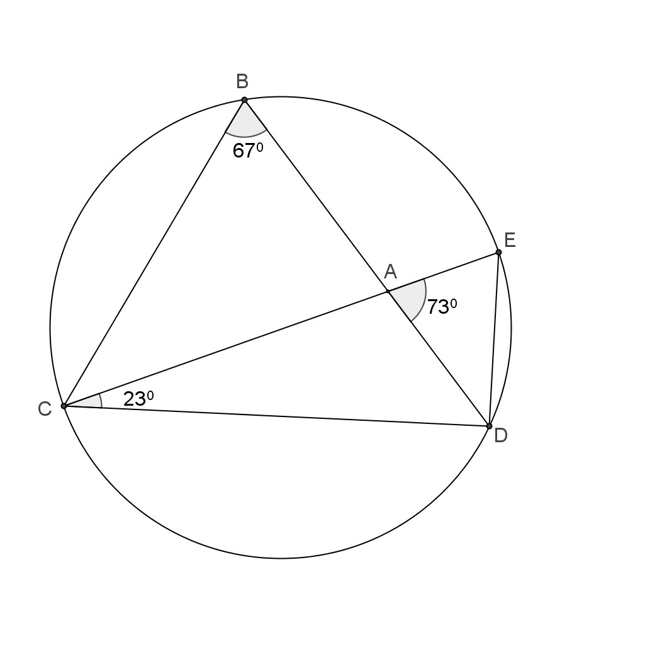

Question 4
[8 marks]
- Prove that $AB×AD=AC×AE$
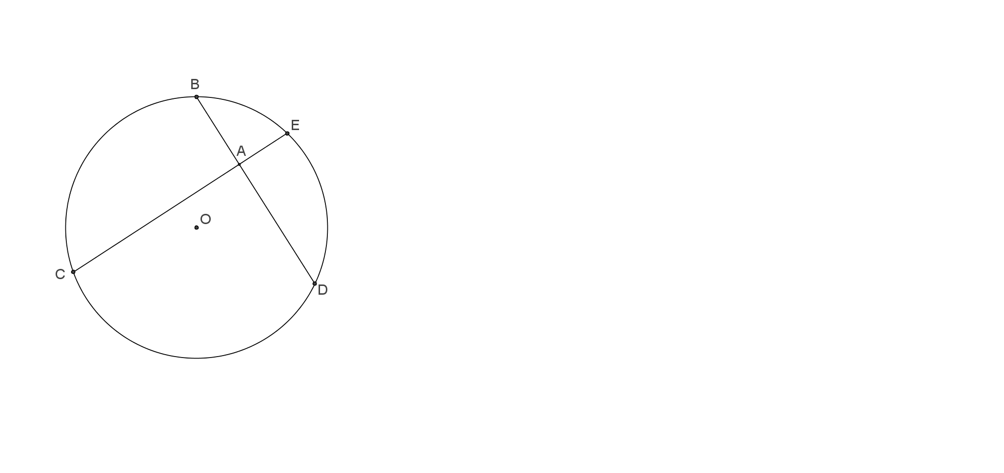

- Given that AB=4cm, AD=6cm and 2AE=AD. Find the length of EC.

Question 5
[5 marks]
Using the method of proof by contradiction, prove that if $3n+2$ is odd then $n$ is odd.

Question 6
[6 marks]
Consider the statement
“If a quadrilateral is a square, then it has 4 equal angles”

- Write the inverse statement.

- Write the converse statement.

- Write the contrapositive statement.

- Which of these statements are false? Give a counter example

Question 7

Determine whether or not $A⇔B$
[2 marks]
A: The two triangles are congruent.
B: The two triangles have corresponding angles equal.

Question 8 [5 marks]

In ΔABC, the points M and N divide the sides AB and AC respectively in the ratio 1 : 3.

Let AB = u and AC = v. Find BC and MN in terms of u and v, and hence prove that BC = 4MN.

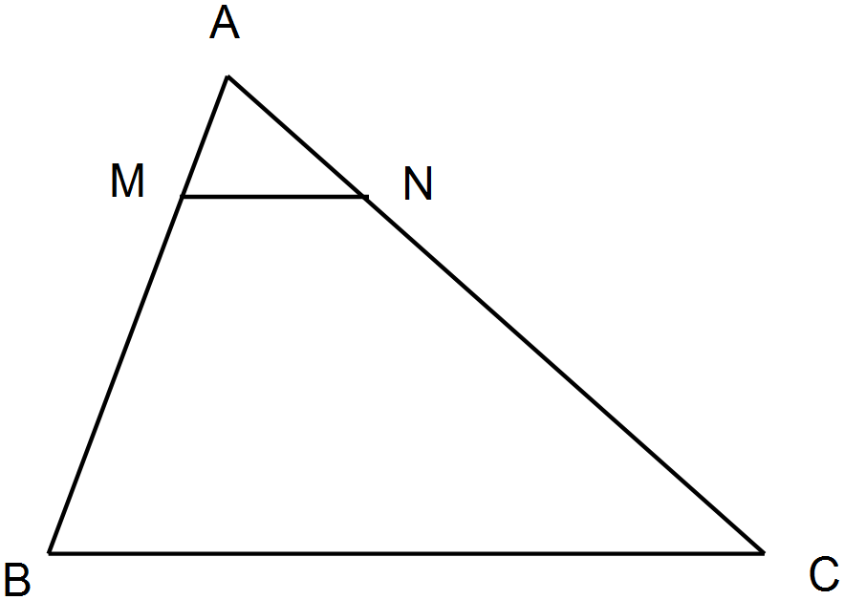

9. [5 marks]

In Triangle ABC below, AD = 13 cm, DB = 5 cm, AE = 9 cm and DE = 5 cm.
Prove that BC = 10 cm.

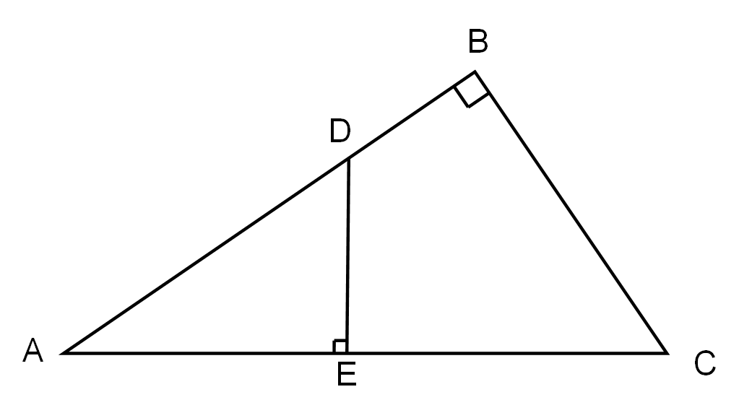

End of Test

